
Department of Computer Science and Engineering
Lab Report
Lab Report No | : | 03
Lab Report Name | : | False Position Method Implementation. F(x)= 3x-cos(x)-1.
Course Title | : | Numerical Methods Sessional
Course Code | : | CSE 226
Name | : | Gazi Rishad Kaiser
ID | : | 1120047
Level | : | 2 | Term | : | 2 | Section | : | A | Group | : | 2
Date of Submission | : | - 2026 | Semester | : | Spring | Year | : | 2026

Problem-03: False Position Method. F(x)= 3x-cos(x)-1.
Key Learnings:
- This program helped in understanding the False Position (Regula Falsi) Method, which is used to find the root of a non-linear equation by using a straight-line approximation between two points.
- The importance of choosing suitable initial values a and b was learned. The method works correctly only when the function values at these points have opposite signs.

Source Code: Input & Output:
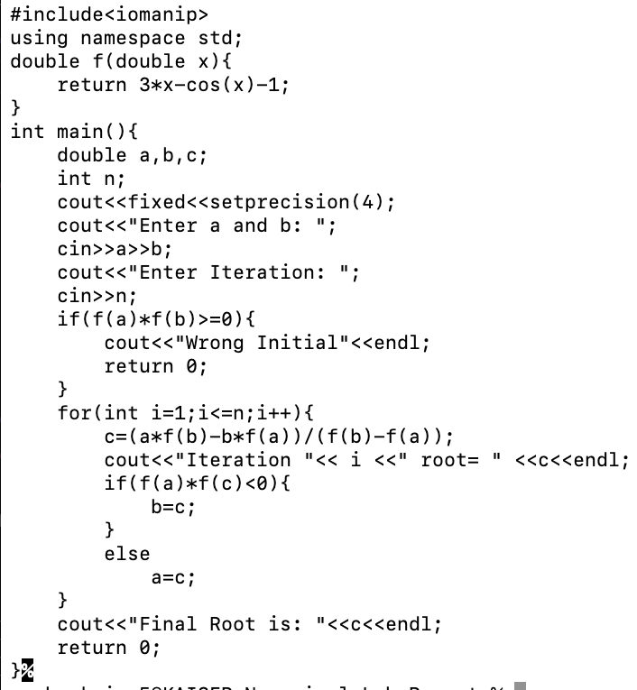
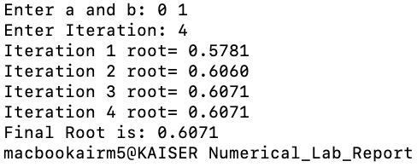

Result Analysis:
Result Analysis:
Result Analysis:
When the program was executed, the values of a, b, and the number of iterations were entered by the user. The function f(x)=3x−cos(x)−1 was evaluated at the given interval. Since the function values at the endpoints had opposite signs, the False Position Method was applied successfully. In each iteration, a new value of c was calculated using the False Position formula. The interval was then updated according to the sign of the function values, which gradually reduced the error in the approximation. As the iterations continued, the estimated root moved closer to the actual solution of the equation. The calculated root value was displayed after each iteration, and a more accurate approximation was obtained with every step. Finally, the root of the equation was successfully determined and printed on the screen.
